MINI PROECT REPORT
ON

ATM MANAGEMENT SYSTEM
Submitted in the partial fulfillment for the ward of degree of Bachelor of Computer Application.



UTTRANCHAL UNIVERSITY
Session 2025-26

SUBMITTED BY
MAYANK SHYAM
Enrol No:
UU2509000215
BCA 2-B
SUBMITTED TO:
Mr. SANJAY MISHRA
Assistant Professor
USCS

ACKNOWLEDGEMENT
The most awaited moment of any endeavour is successful completion, but nothing can be done successfully if done alone. Success is the outcome of contribution and consistent help of various persons and we thank those ones who helped us in successful completion of this project First and foremost, we would like to thanks Prof. (Dr.) Sonal Sharma, Director, USCS for providing a healthy and encouraging environment to study.

We profusely thankful to the Prof. (Dr.) Sameer Dev Sharma, Head of Department, USCS and our project Mentor MR. Sanjay Mishra been generous enough to provide us an opportunity and accepting our candidature for the most valuable guidance and affordable treatment given to us at every stage to boost our morale.

We express our sincere gratitude to our colleagues with whom we have fruitful discussions which have helped us a lot in giving a final shape to the program.

MAYANK SHYAM
BCA (2nd SEMESTER)
EnrolLNO. UU2509000215

DECLARATION

NIKHIL RAWAT student of Bachelor of Computer Applications, hereby declare that the project report entitled ATM Management System submitted to the USCS, Uttaranchal University, Dehradun, is a record of an original work carried by me under the guidance of MR. SANJAY MISHRA and this project work has not been submitted to any other University / College for the sake of award of any degree.

MAYANK SHYAM
BCA-2B
University Roll No. 250900285
CERTIFICATE OF ORIGINALITY

This is to certify that the project entitles “ATM MANAGEMENT SYSTEM” by Mayank Shyam has been submitted in the partial fulfilment of the requirements for the award of the degree of BCA from department of computer applications from Uttaranchal school of computing science Uttaranchal University, Dehradun.

The results embodied in this project have not been submitted to any other University or Institution for the record of any degree.

Under the guidance of:
Mr Sanjay Mishra
Assistant Professor-USCS

TABLE OF CONTENTS
CONTENT
1.INTRODUCTION ………………………………………….………..…...6

2.OBJECTIVE……………………………………………………………....7

3.SYSTEM ANALYSIS……………………………………………………...8

3.IDENTIFICATION OF NEED……………………………………...........9

4.PRELIMINARY INVESTIGATION…………………………………….10

5.FEASIBILITY STUDY…………………………………………………...11

6.PROJECT PLANNING………………………………………………......12

7.PROJECT SCHEDULING (PERT & GANTT CHART)……………...13

8.SOFTWARE REQUIREMENT SPECIFICATIONS (SRS)…………...14

9.SOFTWARE ENGINEERING PARADIGM…………………………....16

10.DATA FLOW DIAGRAM………………………………………………17

11.CONTROL FLOW DIAGRAM…………………………………….…..18

12.STATE DIAGRAM……………………………………………………...19

14.CLASS DIAGRAM……………………………………………………...21

15.ACTIVITY DIAGRAM……………………………………….………...22

16.SYSTEM DESIGN…………………………………………………..…..24

17.TESTING………………………………………………………………....27

18.SYSTEM SECURITY MEASURES……………………………….…...28

19.FUTURE SCOPE………………………………………………………...29

20.APPENDICES (CODING & OUTPUT)………………………………...30

21.BIBLIOGRAPHY………………………………………………………...37

INTRODUCTION
The ATM Management System project developed using the C programming language. In today’s fast-paced world, banking services need to be quick, secure, and easily accessible. Automated Teller Machines (ATMs) play a crucial role in providing 24/7 banking services to customers without the need to visit a bank branch.

This project focuses on simulating the basic functionalities of an ATM system such as account management, balance inquiry, cash withdrawal, deposit, and transaction history. It helps in maintaining user account records in an organized and efficient manner, reducing manual errors and saving time.

The system is designed to provide a simple and user-friendly interface for both administrators and customers. The administrator can manage user accounts, monitor transactions, and maintain records securely. On the other hand, customers can securely access their accounts, check balances, withdraw or deposit money, and view transaction details.

Overall, this project demonstrates how a computerized system can improve banking efficiency, ensure data accuracy, and provide better service to users through automation.

OBJECTIVE
- To design and develop a secure ATM Management System that allows users to perform basic banking operations such as login, balance inquiry, cash withdrawal, deposit, and fund transfer in a simple and user-friendly manner.

- To ensure data accuracy and security by implementing proper authentication using PIN, maintaining transaction records, and preventing invalid operations like overdrawing beyond available balance.

- To provide administrative control for managing user accounts, including creating new accounts, updating account details, and monitoring all transactions efficiently.

- To create an organized system that maintains complete transaction history, reduces manual work, minimizes errors, and simulates real-world ATM functionality using the C programming language.

SYSTEM ANALYSIS
System analysis is an important step in developing the ATM Management System, as it helps in understanding existing problems and defining system requirements. In the current banking system, customers often face long queues at bank branches for basic services like balance inquiry and cash withdrawal. Although ATMs are available, some systems are not user-friendly and may be difficult for non-technical users to operate. Manual processes can also lead to errors and delays.

After analyzing the existing system, key problems identified include slow transaction processing, unclear user instructions, security concerns, and limited administrative control. Customers require a system that is fast, secure, and easy to use, while administrators need efficient tools to manage accounts and monitor transactions.

To overcome these issues, the proposed ATM Management System provides a secure login using PIN authentication and allows users to perform essential operations such as cash withdrawal, balance checking, and fund transfer. The system ensures real-time transaction processing and displays clear instructions for better user understanding. It also includes an admin module for managing accounts and maintaining transaction records.

The system is designed by considering both customer and admin requirements, ensuring ease of use, security, and efficiency. It is technically and economically feasible, as it can be developed using basic programming tools with low cost.

PROJECT PLANNING

Project planning is all about making sure we know what we are doing, when we are doing it, and how. Without a plan, even a small project can become a mess of confusion and missed deadlines.
For the ATM Management System, we broke the entire project into clear phases:

• Week 1 — Requirements Gathering: We sat together and listed out everything the system
needs to do. What features does the customer need? What does the admin need? What data
needs to be stored?

• Week 2 — System Design: We designed the overall structure of the program — what
modules we would create, how they would talk to each other, and how data would flow
through the system.

• Week 3 — Core Development: We started coding the main modules — authentication, cash withdrawal, balance inquiry, and fund transfer. Each one was built and tested individually.

• Week 4 — Admin Module + Integration: We built the admin features and then brought all the modules together into one working system.

• Week 5 — Testing and Documentation: We ran the system through various test cases to
catch bugs, fixed the issues we found, and then wrote up the documentation.

This structured approach made sure that every part of the system got proper attention.
It also helped us catch problems early — before they became bigger issues that would be harder to fix later.

IDENTIFICATION OF NEED

The need for an ATM Management System arises from the limitations of traditional banking services and the growing demand for fast, reliable, and accessible financial transactions. In many areas, especially in small towns and semi-urban regions, people still depend heavily on bank branches for basic tasks such as withdrawing cash or checking account balances. This often leads to long queues, limited service hours, and inconvenience for customers.
Even though ATMs are available, existing systems sometimes face issues such as improper record maintenance, cash shortages, and failed transactions without clear explanations. These problems reduce user trust and make the banking experience less efficient.
A well-designed ATM Management System helps address these challenges by providing 24/7 access to banking services, reducing dependency on bank branches, and minimizing human errors through automation. It ensures accurate and real-time recording of all transactions, improving transparency and reliability. Additionally, it allows administrators to monitor cash levels and account activities effectively, ensuring smooth system operation.
The system also focuses on providing a simple and user-friendly interface so that customers can perform transactions easily and confidently. Overall, the need for this system comes from bridging the gap between current banking limitations and the modern requirement for speed, convenience, and security.

PRELIMINARY INVESTIGATION

Preliminary investigation is the first step in determining whether a project is feasible and worth developing. It involves studying the existing system, understanding how it works, and identifying the key requirements needed for improvement. For this project, we analyzed the working process of real-world ATM systems to understand how transactions are performed and managed.

During the investigation, we observed that an ATM system follows a structured process where a user inserts a card, enters a PIN for authentication, selects a transaction type, and completes the operation. We also identified the essential data required for the system, such as account numbers, PINs, account balances, and transaction records.

The study highlighted some important aspects of ATM systems. Authentication is the most critical part, ensuring that only authorized users can access their accounts through secure PIN verification. Every transaction must be processed instantly, updating the account balance and maintaining proper records to avoid discrepancies. Additionally, the system requires an admin module to manage user accounts, monitor cash availability, and maintain system operations effectively.

The investigation also revealed the need for proper error handling, such as managing incorrect PIN attempts, insufficient balance, or system failures, to ensure a smooth user experience. Based on these findings, it was concluded that the project is both necessary and feasible. The requirements are clear, the system scope is manageable, and it can be successfully implemented using the C programming language within the given timeframe.

FEASIBILITY STUDY

A feasibility study is conducted to evaluate whether a project can be successfully developed and implemented. It analyzes the project from technical, economic, and operational perspectives to ensure practicality and effectiveness.

From a technical point of view, the ATM Management System is highly feasible. The project is developed using the C programming language, which is widely used and well understood by students. The required concepts such as input/output operations, conditional statements, loops, and file handling are basic programming topics. The tools needed, such as a C compiler like Dev C++ or GCC, are simple and easily available, making the development process straightforward.

From an economic perspective, the project is very cost-effective. It does not require any expensive software or hardware. The tools used for development are free, and the system can be built using standard computers available in colleges or at home. Therefore, the overall cost of development is minimal, making it economically feasible.

From an operational point of view, the system is designed to be user-friendly and easy to operate. Customers can easily perform transactions using a simple menu-driven interface, even if they are using the system for the first time. Similarly, the admin features are clear and manageable, allowing smooth handling of accounts and transactions.

PROJECT SCHEDULING (PERT & GANTT CHART)

PERT Chart (Program Evaluation and Review Technique)
PERT is a planning tool that helps map out all the tasks in a project and understand which ones depend on others. For the ATM Management System, the PERT chart looks like this:
Activity A — Requirements Gathering (1 week) → 
Activity B — System Design (1 week) → 
Activity C — Module Design (1 week) → 
Activities D, E, F — Core Coding: Authentication,
Transaction Modules, Admin Module (2 weeks, run in parallel) → 
Activity G — Integration (1 week) → 
Activity H — Testing (1 week) → 
Activity I — Documentation and Final Review week).
The critical path runs through A → B → C → D → G → H → I, totaling approximately
8 weeks.
Activities E and F run alongside D and do not extend the total duration.

Gantt Chart
The Gantt chart below shows the week-by-week timeline of the ATM Management
System project.

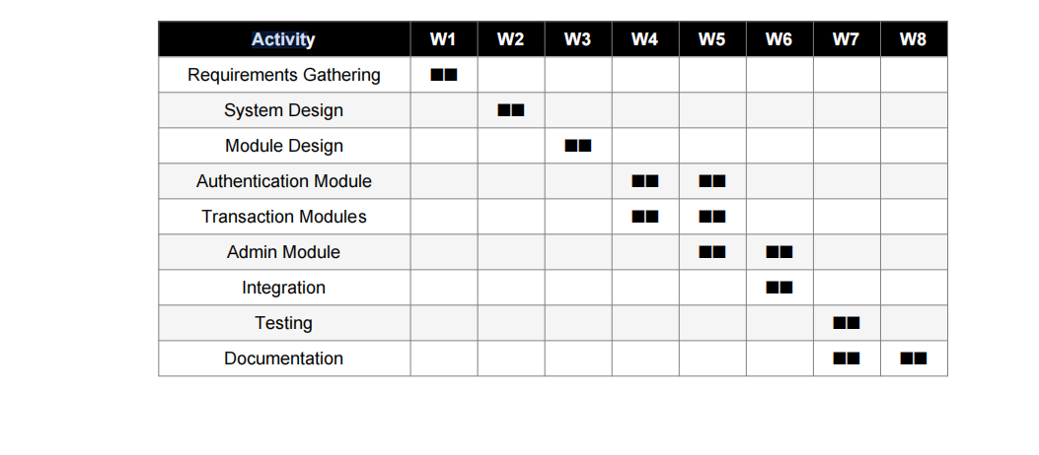
Activity:

9.

SOFTWARE REQUIREMENT SPECIFICATIONS (SRS)

1. Functional Requirements
• The system shall authenticate users using a card number and a 4-digit PIN.
• The system shall allow customers to withdraw cash, subject to available balance.
• The system shall display the current account balance upon request.
• The system shall support fund transfers between accounts within the system.
• The system shall maintain a log of all transactions with date, time, and amount.
• The system shall allow admins to create, update, and deactivate user accounts.
• The system shall provide a login and logout mechanism for both customers and admins.
• The system shall lock an account after three consecutive wrong PIN attempts.

2. Non-Functional Requirements
• Performance: Transactions should be processed and confirmed within 2 seconds.
• Usability: The interface should be menu-driven and easy to navigate even for first-time users.
• Security: PINs must be stored securely and never displayed on screen in plain text.
• Reliability: The system should be stable and not crash during normal use.
• Scalability: The system should be able to handle up to 500 accounts without performance issues.

3. Hardware Requirements
• Processor: Intel Core i3 or above.
• RAM: Minimum 2 GB.
• Storage: At least 20 GB of free disk space.
• Operating System: Windows 7 / Windows 10 / Linux.

4. Software Requirements
• Programming Language: C
• Compiler: Dev C++ or GCC
• Operating System: Windows 10 / Linux
• Text Editor: VS Code / Notepad++

SYSTEM DESIGN

1. Data Flow Diagram (DFD)
A Data Flow Diagram shows how data moves through the system — who puts data in, what processes handle it, and where it goes after. Think of it as a map of information flow.
For the ATM Management System, the main external entities are the Customer and the Admin.

The Customer interacts with the system by entering a card number and PIN, selecting a
transaction, and receiving a result. The Admin interacts by managing accounts and
checking logs.

The central process is the ATM Core System, which handles authentication, transaction
processing, and record keeping. It reads from and writes to two key data stores — the Accounts Database (which holds account details and balances) and the Transaction Log
(which records every operation). The system also connects to the Bank Server for verifying account status and processing inter-bank transfers.

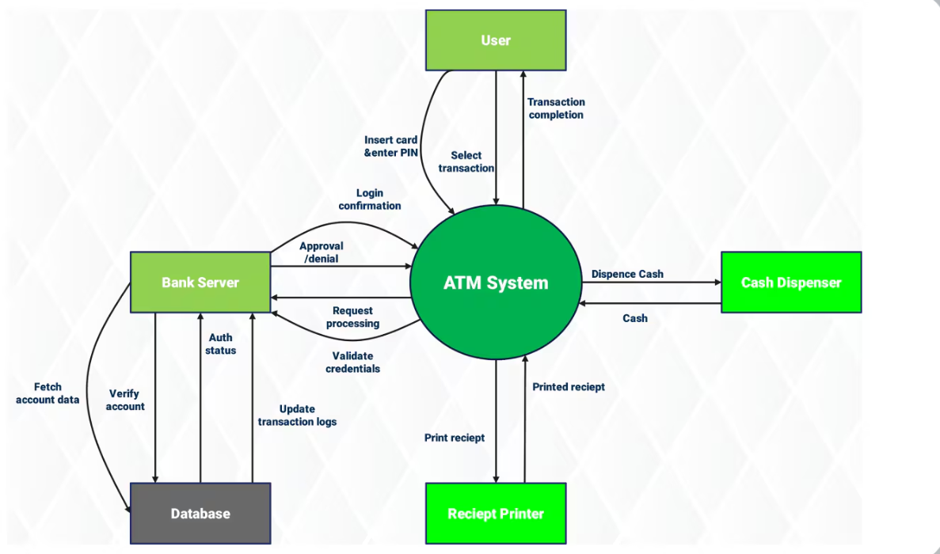

2. State Diagram
A State Diagram shows all the different states a system can be in, and what causes it to
move from one state to another. It is very useful for showing the lifecycle of a system.
The ATM Management System has the following key states: Idle (waiting for a card), Card Inserted, PIN Entry, Authenticated, Menu Display, Transaction Processing (with sub-states for Withdrawal, Balance Check, and Transfer), Transaction Complete, Error State, and back to Idle.

Each transition is triggered by a specific user action or system event — like entering a
correct PIN, selecting an option, or completing a transaction.

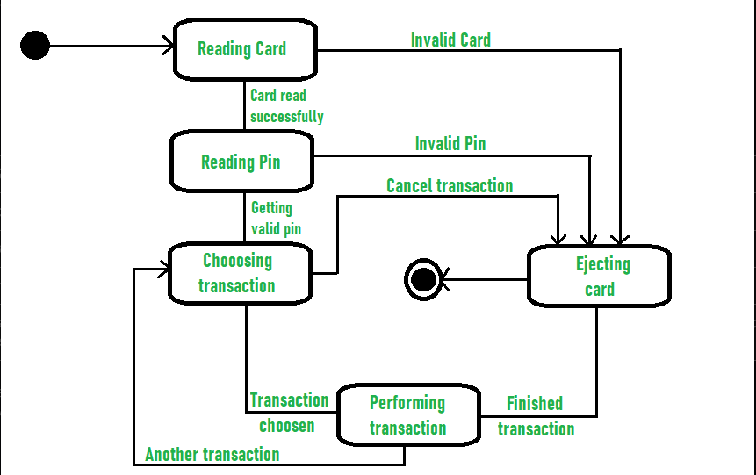

3. Class Diagram
A Class Diagram describes the structure of the system in terms of classes (or in C, structured data types), their attributes, and how they relate to each other.
The main classes in this system are: ATM (with attributes like ATM ID, location, and cash balance, and methods like authenticate and dispense Cash), Account (with account number, PIN, and balance, and methods like get Balance, debit, and credit), Transaction (with type, amount, date, and methods like process and log), Customer (with name, ID, and methods like login and view History), Admin (with methods like refill Cash and view Logs), and Bank (responsible for verifying accounts and processing transfers).

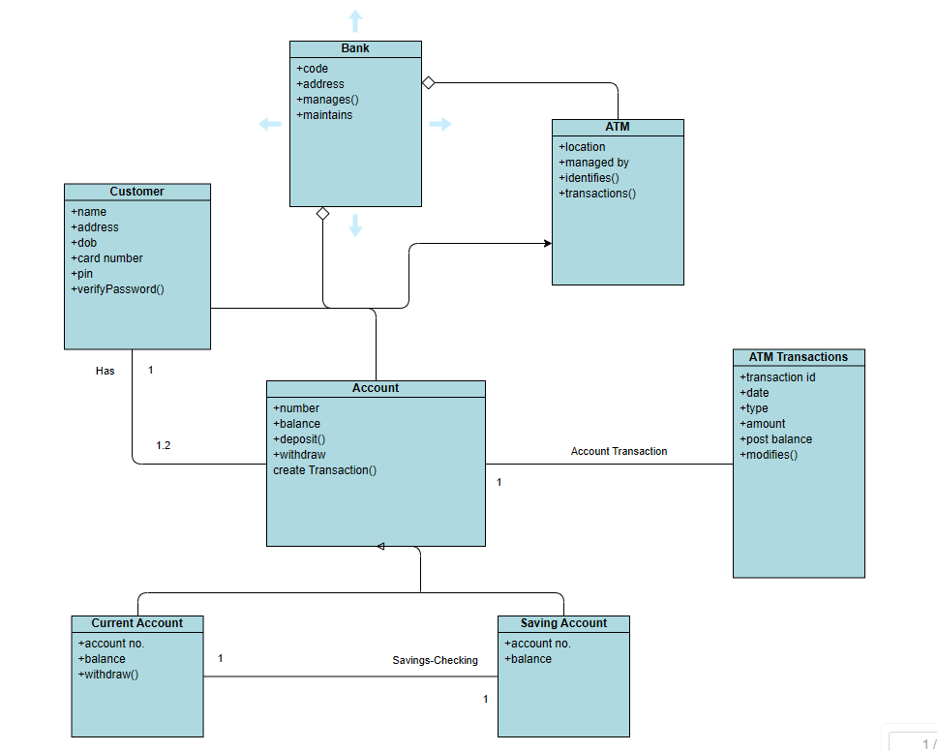

4. Activity Diagram

An Activity Diagram is like a detailed flowchart that shows the workflow of a process, including decision points and parallel activities.The main activity flow for the ATM starts with the customer inserting their card. The system checks the card, asks for a PIN, and validates it. If valid, the main menu is shown.

The customer selects an option — if they choose Withdraw, the system checks the balance, processes the withdrawal, updates the record, and dispenses cash. If Balance Check is selected, the current balance is displayed. If Transfer is chosen, the target account is validated and the amount is moved. After any transaction, the system asks if the customer wants to do another. If not, the card is ejected and the session ends.

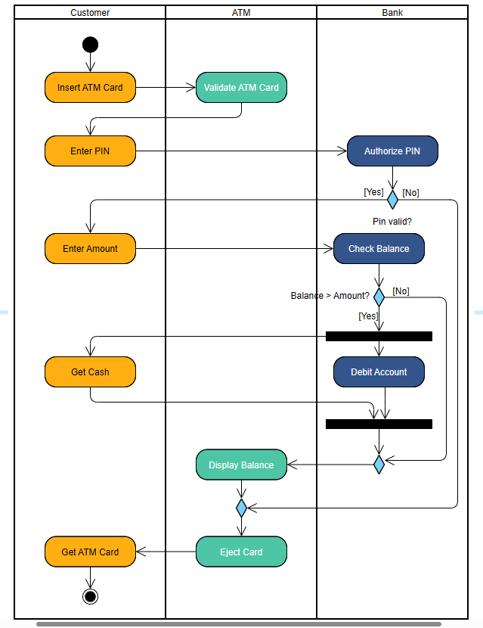

TESTING

Testing is the part where we make sure the system actually does what it is supposed to do — and that it handles unexpected situations without crashing or behaving weirdly. We applied several testing strategies

Unit Testing
Each module was tested separately before being combined. For example, the authentication module was tested with correct PINs, wrong PINs, and locked account scenarios — all before connecting it to the transaction module

Integration Testing
Once all modules were ready, we connected them and tested the full flow — from card insertion to transaction completion. This helped us catch issues that only show up when modules interact with each other.

Black Box Testing
We tested the system purely from the user's perspective — giving inputs and checking outputs, without looking at the code. This helped us verify that the system behaves correctly from the outside.

White Box Testing
Here we examined the code logic directly and made sure every possible path — including edge cases — was covered. For example, we checked what happens if someone tries to withdraw exactly the amount in their account, or if they enter an amount of zero.

SYSTEM SECURITY MEASURES

Security is not just an add-on in a banking system — it is the foundation. The ATM Management System incorporates several security measures to protect both the customer's money and their personal data.

• Authentication: Every session starts with a two-factor check — the card number and the
PIN. Without both, no one can access an account.

• Account Lockout: After three consecutive wrong PIN entries, the account is automatically locked to prevent brute-force attacks.

• Role-Based Access Control: Customers can only see and manage their own account.
Admin functions are completely separate and only accessible with admin credentials.

• Data Validation: All input fields are validated. The system rejects invalid amounts (like zero or negative numbers), non-existent account numbers, and entries that fall outside expected ranges
.
• Transaction Logging: Every action — successful or failed — is recorded with a timestamp. This creates a clear audit trail and helps in resolving disputes or identifying suspicious activity.

• Session Management: Each customer session is properly started and ended. Once a
customer logs out or the session times out, no further actions can be performed without
logging in again.

• Secure PIN Storage: PINs are not displayed on screen in plain text at any point during the session, minimizing the risk of shoulder-surfing or accidental exposure. While this project is a simplified academic implementation, these security principles directly mirror the practices used in real-world banking systems.

FUTURE SCOPE AND FURTHER ENHANCEMENT

The current version of the ATM Management System is a solid foundation, but there is a lot of room to grow. Here are some improvements that could make the system significantly more powerful and practical in the future:

• Database Integration: Right now, data is stored in files. Moving to a proper database like
MySQL or SQLite would make the system faster, more secure, and able to handle a much
larger number of accounts.

• Mobile Banking Integration: A companion mobile app could allow users to check balances, initiate transfers, and receive transaction alerts from their phone — without even needing a physical ATM

• OTP-Based Authentication: Adding One-Time Password (OTP) verification through SMS or email would provide an extra layer of security on top of the existing PIN system.

• Biometric Authentication: Fingerprint or facial recognition could eventually replace or
supplement the PIN system, making it even more secure and convenient.

• Real-Time Bank Server Connection: Connecting the system to a real banking network
would allow inter-bank transfers, real-time balance updates, and connectivity with multiple branches.

• Multi-Currency Support: For international use, the system could be upgraded to handle
multiple currencies and automatic conversion rates.

• ATM Cash Management: A smart cash-monitoring system could automatically alert
administrators when cash levels are low, reducing downtime and customer inconvenience.

• Graphical User Interface (GUI): The current system uses a text-based menu. A proper GUI built with a framework like Qt or even a web-based interface would make it more modern and user-friendly.

• Artificial Intelligence: AI could be used to detect unusual transaction patterns and flag
potential fraud before any damage is done. Each of these enhancements represents a natural next step in the evolution of this system. The current project lays the groundwork — the future can build on top of it.

Appendices:

- Coding:

#include <stdio.h>
#include <stdlib.h>
#include <string.h>
#include <time.h>

#define MAX_TRANSACTIONS 5

struct Transaction {
float amount;
char type[10];
char time[30];
};

struct ATM {
int pin;
float balance;
struct Transaction transactions[MAX_TRANSACTIONS];
int transIndex;
};

// Time function
void getTime(char *buffer) {
time_t t;
time(&t);
snprintf(buffer, 30, "%s", ctime(&t));
}

// Save data
void saveData(struct ATM *user) {
FILE *fp = fopen("atmdata.dat", "wb");
if (fp != NULL) {
fwrite(user, sizeof(struct ATM), 1, fp);
fclose(fp);
}
}

// Load data
void loadData(struct ATM *user) {
FILE *fp = fopen("atmdata.dat", "rb");

if (fp == NULL) {
user->pin = 1234;
user->balance = 5000;
user->transIndex = 0;

for (int i = 0; i < MAX_TRANSACTIONS; i++) {
user->transactions[i].amount = 0;
strcpy(user->transactions[i].type, "");
strcpy(user->transactions[i].time, "");
}

saveData(user);
} else {
fread(user, sizeof(struct ATM), 1, fp);
fclose(fp);
}
}

// Delay
void delay() {
for (long i = 0; i < 50000000; i++);
}

// Loading animation
void loading() {
printf("Processing");
for (int i = 0; i < 3; i++) {
printf(".");
delay();
}
printf("\n");
}

// Stylish header
void header() {
printf("\n=====================================\n");
printf(" ATM MANAGEMENT SYSTEM 💳\n");
printf("=====================================\n");
}

// Receipt
void printReceipt(float amount, float balance, char type[]) {
printf("\n---------- RECEIPT ----------\n");
printf("Type : %s\n", type);
printf("Amount : %.2f\n", amount);
printf("Balance : %.2f\n", balance);
printf("-----------------------------\n");
}

int main() {
struct ATM user;
loadData(&user);

int enteredPin, attempts = 0;
int choice;
float amount;

header();

// PIN check
while (attempts < 3) {
printf("Enter PIN: ");
scanf("%d", &enteredPin);

if (enteredPin == user.pin)
break;
else {
attempts++;
printf("Wrong PIN! Attempts left: %d\n", 3 - attempts);
}
}

if (attempts == 3) {
printf(" Account Blocked!\n");
return 0;
}

do {
printf("\n========== ATM MENU ==========\n");
printf("1. Check Balance\n");
printf("2. Deposit\n");
printf("3. Withdraw\n");
printf("4. Change PIN\n");
printf("5. Add 5%% Interest\n");
printf("6. Mini Statement\n");
printf("7. Exit\n");
printf("==============================\n");
printf("Enter choice: ");
scanf("%d", &choice);

switch (choice) {

case 1:
printf("\n Current Balance: %.2f\n", user.balance);
if (user.balance < 1000)
printf("Low Balance Warning!\n");
break;

case 2:
printf("Enter amount: ");
scanf("%f", &amount);

if (amount > 0) {
loading();

user.balance += amount;

int idx = user.transIndex % MAX_TRANSACTIONS;
user.transactions[idx].amount = amount;
strcpy(user.transactions[idx].type, "Deposit");
getTime(user.transactions[idx].time);

user.transIndex++;
saveData(&user);

printf(" Deposit Successful!\n");
printReceipt(amount, user.balance, "Deposit");
} else {
printf(" Invalid Amount!\n");
}
break;

case 3:
printf("Enter amount: ");
scanf("%f", &amount);

if (amount > 10000) {
printf(" Limit Exceeded! Max 10000\n");
}
else if (amount > 0 && amount <= user.balance) {
loading();

user.balance -= amount;

int idx = user.transIndex % MAX_TRANSACTIONS;
user.transactions[idx].amount = amount;
strcpy(user.transactions[idx].type, "Withdraw");
getTime(user.transactions[idx].time);

user.transIndex++;
saveData(&user);

printf(" Withdrawal Successful!\n");
printReceipt(amount, user.balance, "Withdraw");
} else {
printf(" Insufficient Balance!\n");
}
break;

case 4: {
int newPin, confirmPin;

printf("Enter New PIN: ");
scanf("%d", &newPin);

printf("Confirm PIN: ");
scanf("%d", &confirmPin);

if (newPin == confirmPin) {
user.pin = newPin;
saveData(&user);
printf(" PIN Changed Successfully!\n");
} else {
printf(" PIN mismatch!\n");
}
break;
}

case 5:
loading();
user.balance += user.balance * 0.05;
saveData(&user);
printf("5%% Interest Added!\n");
break;

case 6:
printf("\n------ MINI STATEMENT ------\n");
for (int i = 0; i < MAX_TRANSACTIONS; i++) {
if (user.transactions[i].amount != 0) {
printf("%s | %.2f | %s",
user.transactions[i].type,
user.transactions[i].amount,
user.transactions[i].time);
}
}
break;

case 7:
printf("\n=====================================\n");
printf(" Thank You For Using ATM \n");
printf("=====================================\n");
printf(" Developed By:\n");
printf(" -> Nikhil & Mayank <-\n");
printf("=====================================\n");
break;

default:
printf(" Invalid Choice!\n");
}

} while (choice != 7);

return 0;

OUTPUT

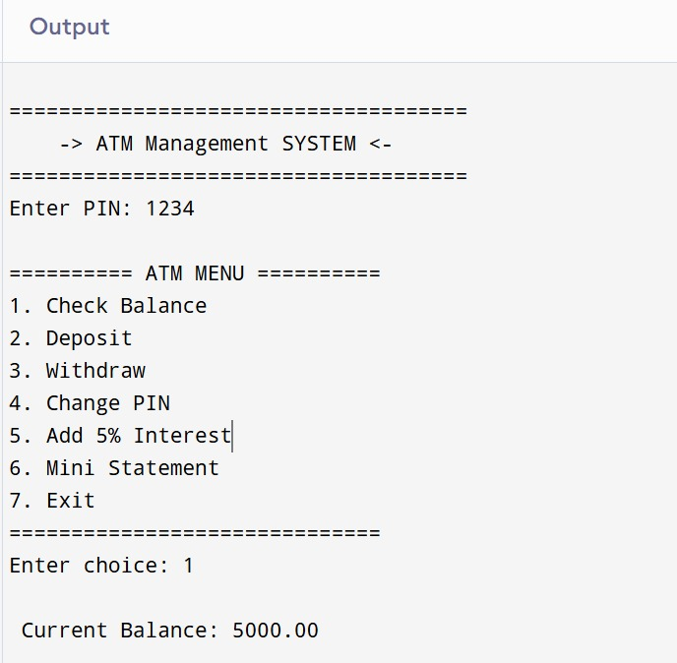
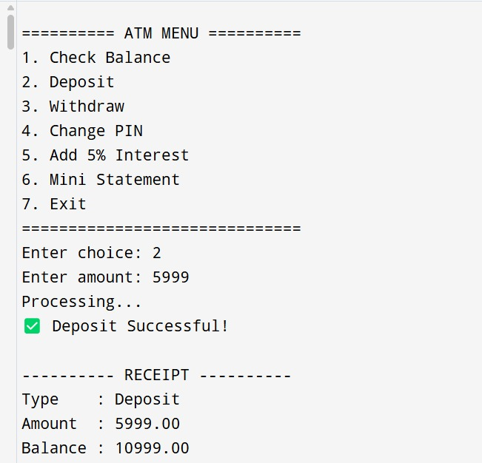
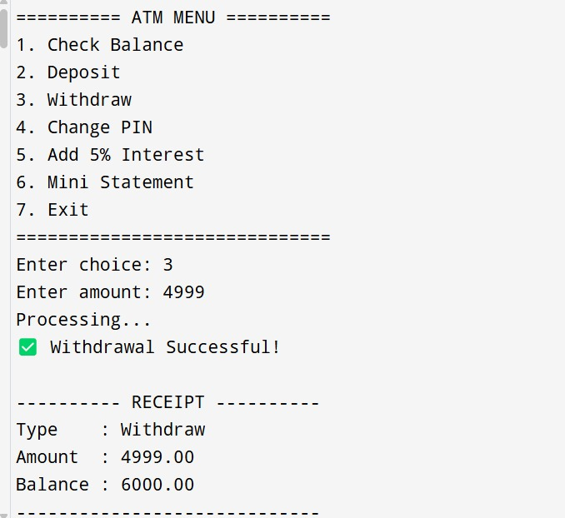
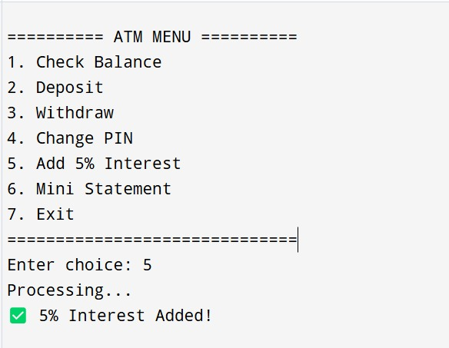
- 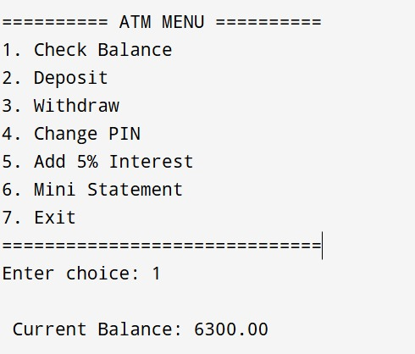

- 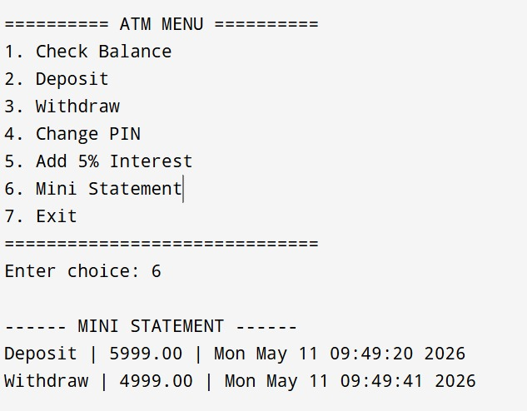

- 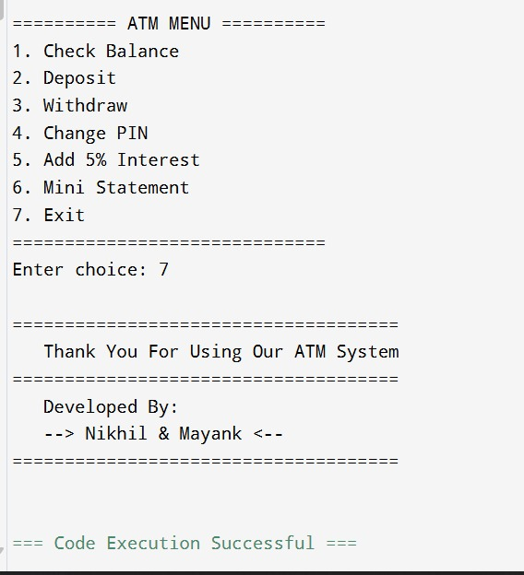

- Bibliography

The development of this project was supported by various resources, including books, online documentation, and tutorials. Below are the key references used during the project:

- Books & Study Materials :

1.Computer Fundamentals And Programming in c: By, Reema Thareja
2. Programming in C: Arvind Kumar Gupta

- Websites:

https://worldline.com/en-ee/home/main-navigation/solutions/financial- institutions/atm-management

